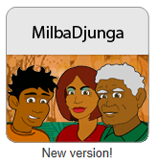
MilbaDjunga

- Interactive online primary and secondary units to support teachers of Aboriginal and Torres Strait Islander students to teach consumer and financial literacy.

- Year 5 and 6 unit: Do I need it? Do I want it? How can I get it? Provides guidance on how to set up a classroom economy which gives students the skills to achieve their goals by getting into the habit of earning and budgeting while in a supported school environment. Skills needed for bill paying, shopping and banking are practised with students learning about budgeting and saving.

- Year 9 unit: How can I start my own business?
Builds on the knowledge and skills gained in the primary unit and gives students the opportunity to explore the different ways that people can get money, why people work, how money comes into communities and how, by starting their own small business, they can make money and benefit their community at the same time.

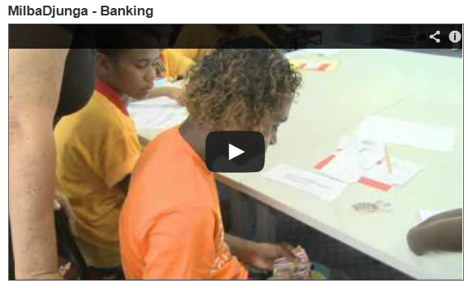

The units are supported by extensive Teacher notes, online activities and student materials and a set of videos.
You can access MilbaDjunga from the Moneysmart teaching Resource centre
https://www.moneysmart.gov.au/teaching/teaching-resources

